**Mahendra Kumar Ponnapalli**

**PIZZA SALES REPORT**

**Key Performance Indicators using MySQL:**

1. **Total Revenue:**

SELECT SUM(total_price) AS Total_Revenue FROM [dbo].[Mahi( Pizza Project)];

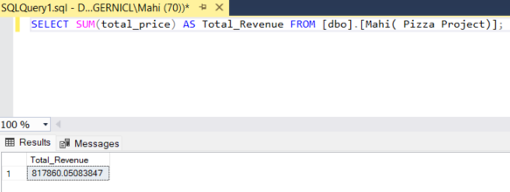

1. **Average Order value:**

SELECT (SUM(total_price) / COUNT(DISTINCT order_id)) AS Avg_order_Value FROM [dbo].[Mahi( Pizza Project)]

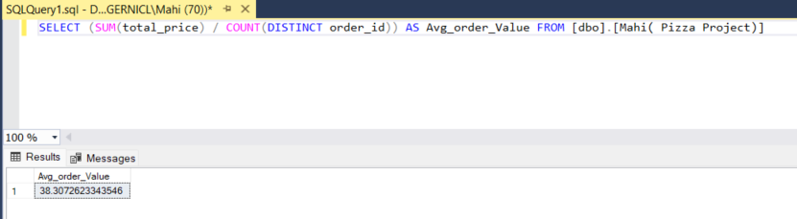

1. **Total Pizzas Sold:**

SELECT count(pizza-id) AS Total_pizza_sold FROM [dbo].[Mahi( Pizza Project)]

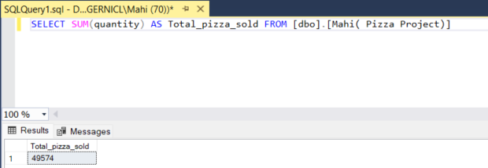

1. **Total orders :**

SELECT COUNT(DISTINCT order_id) AS Total_Orders FROM [dbo].[Mahi( Pizza Project)]

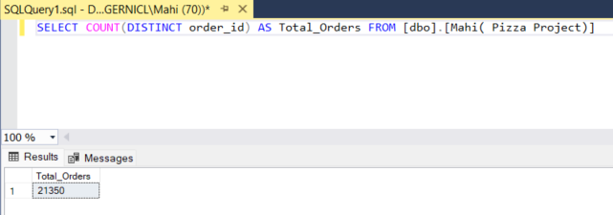

5.**Average Pizzas per order :**

SELECT CAST(CAST(SUM(quantity) AS DECIMAL(10,2)) /

CAST(COUNT(DISTINCT order_id) AS DECIMAL(10,2)) AS DECIMAL(10,2))

AS Avg_Pizzas_per_order

FROM [dbo].[Mahi( Pizza Project)]

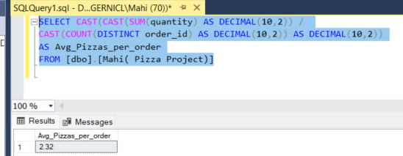

**CHART REQUIREMENTS:**

1. Daily Trend for total orders:

SELECT DATENAME(DW, order_date) AS order_day, COUNT(DISTINCT order_id) AS total_orders

FROM [dbo].[Mahi( Pizza Project)]

GROUP BY DATENAME(DW, order_date)

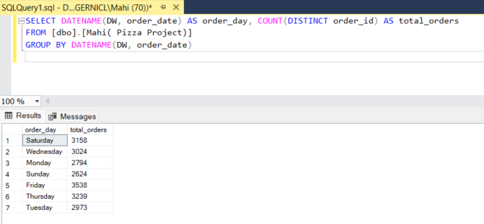

1. Hourly trend for total order:

select DATEPART(hour,order_time) as order_hours,count(distinct(order_id)) as total_sales

from [Mahi( Pizza Project)]

group by DATEPART(hour,order_time)

order by order_hours

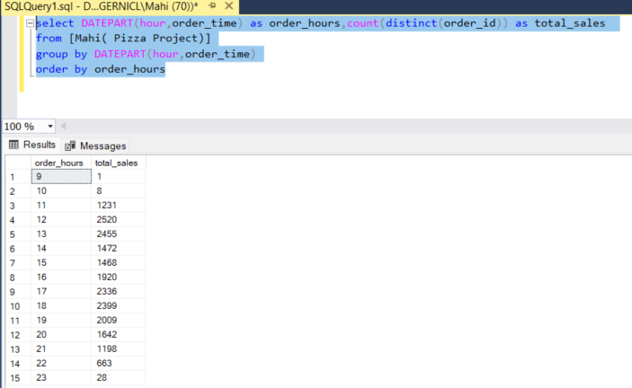

1. Percentage of Sales by Pizza- category

select pizza_category, sum(total_price) as Total_sales,sum(total_price) * 100 / (Select sum(total_price) from [Mahi( Pizza Project)] where month(order_date)=1) as PCT

from [Mahi( Pizza Project)]

where month(order_date)= 2

group by pizza_category

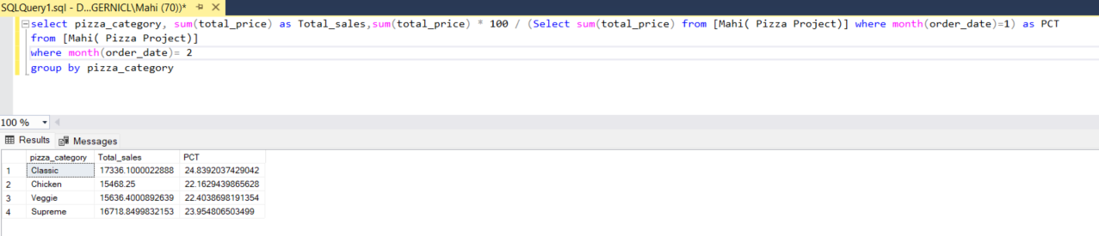

1. Percentage of sales by Pizza_size

select pizza_size, sum(total_price) as Total_sales,sum(total_price) * 100 / (Select sum(total_price)

from [Mahi( Pizza Project)] where month(order_date)=1) as PCT

from [Mahi( Pizza Project)]

where month(order_date)= 2

group by pizza_size

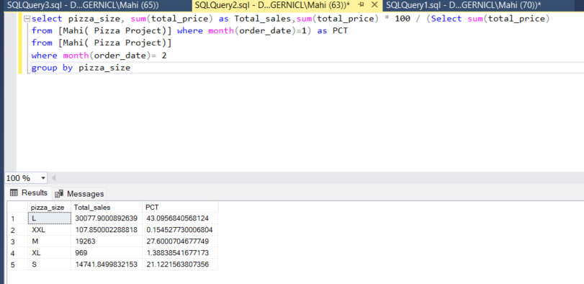

1. Total pizzas sold by Pizza category :

select pizza_category, Count(quantity) as Pizza_sales from [Mahi( Pizza Project)]

group by pizza_category

order by Pizza_sales asc

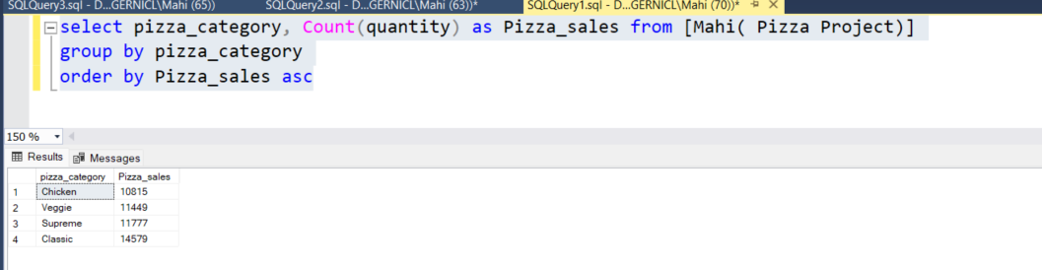

1. **Top 5 Best Pizzas**

SELECT pizza_name, Pizza_sales

FROM (

SELECT pizza_name,

COUNT(quantity) AS Pizza_sales,

DENSE_RANK() OVER (ORDER BY COUNT(quantity) DESC) AS rnk

FROM [Mahi( Pizza Project)]

GROUP BY pizza_name

) ranked

WHERE rnk <= 5;

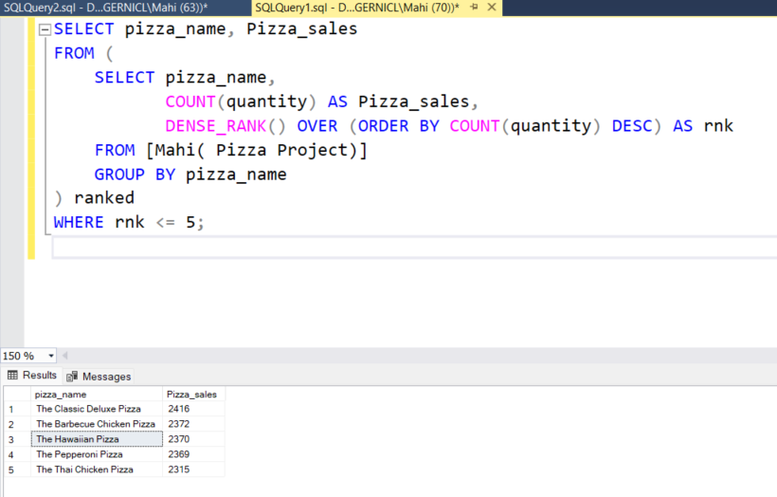

1. **Worst 5 selling Pizzas** :

SELECT pizza_name, Pizza_sales

FROM (

SELECT pizza_name,

COUNT(quantity) AS Pizza_sales,

DENSE_RANK() OVER (ORDER BY COUNT(quantity) asc) AS rnk

FROM [Mahi( Pizza Project)]

GROUP BY pizza_name

) ranked

WHERE rnk <= 5;

